TALL TIMBER RANCH

Dear Friends and Supporters of Tall Timber; January 31, 2015
As we wrap up 2014 and ring in 2015, we do so with more than a few mixed emotions. As many of you know, we (Stan and Becky) are retiring at the end of January as Tall Timber’s Executive Director and Assistant Director. We have been hearing many similar questions recently, so here are a few answers:
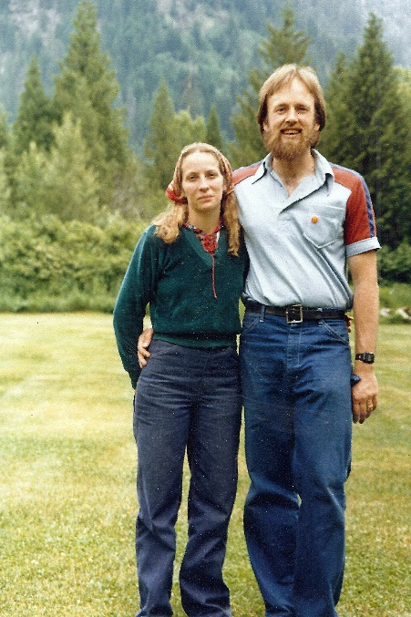
(Stan and Becky, 1980) How long have you been at Tall Timber? We began on May 1, 1980 on a Presbyterian mission grant to develop Program and do PR. Three years later, we were hired as Tall Timber Ranch’s first full time, year round employees. Last summer was our 35th summer at camp!

Why are you leaving? You’re not old! Well, thanks, but sometimes we feel the years! On a personal level, we want to be healthy enough to still enjoy some adventures of our own during our retirement.
For camp, we felt it was a good time for someone with new energy and vision to connect with the next generation of young families, children and teens. The time felt right on both counts.
What will you be doing? Where are you going? We will not be moving from our home at Lake Wenatchee. We love the area and own our home. And we will actually not be leaving Tall Timber’s employ entirely quite yet. Stan will remain in a part time capacity for up to 3 years as the “Associate for Development and Public Relations”. In this capacity, he will be helping with fund raising tasks, assisting with things like the website, publications, and transition needs. Becky will no longer be employed, but may still assist some with these tasks. You can continue to contact us at stan@talltimber.org and becky@talltimber.org. On the personal side, we hope to do some travel and adventures, home improvement projects, continue involvement with local music activities, and enjoy time with our growing family.
Will there be a party for you? An event is being planned for the first weekend of May at Tall Timber. This will be almost 35 years to the day that we began our employment. Members of the Personnel Committee and our children (a scary thought!) are working on plans. The entire weekend will be dedicated to a reunion of paid Tall Timber staff, year round or summer. A luncheon and party on Saturday May 2nd are open to anyone. Watch the website and Facebook page for more to come.
What’s the best way to express our appreciation for your time at Tall Timber?
We get asked this a lot, and feel so honored! So here are a few ideas:
If you have old pictures or video footage of us or our family at camp, we would love to get a copy! Stan was usually behind the camera taking pictures of campers and we honestly have very few pictures of ourselves to document a 35 year career.
Also, favorite memories, or ways Tall Timber has impacted your life would be incredibly wonderful and meaningful to us. You can email, write, send us a video comment or best of all, tell us in person.

Lastly, the Tall Timber Board has created a new fund called the Fishburn Legacy Fund. Its purpose will be initially to finance the 3 year part time transition position Stan will be doing and also build an ongoing fund for support of Tall Timber year round staff. Personnel costs are Tall Timber’s largest single financial need, so a fund dedicated to supporting the wonderful folks who serve there is a wonderful and practical goal. Donations to this fund would be a deeply meaningful way to honor us. You can donate online at the “Give” or “Support” link on the website, or contact Cathi in the office at 509 763-3127 cathi@talltimber.org .
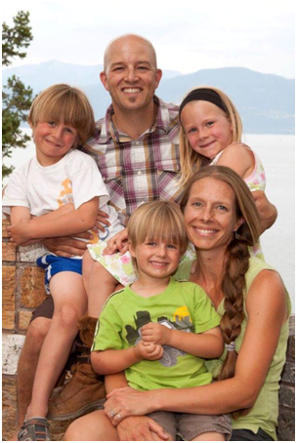
Has a new Director been hired? Yes! We are thrilled that after a long and extensive search, the Tall Timber Board has hired Dave Saugen to be the new Executive Director. Dave grew up in the Whidbey Presbyterian Church and attended Tall Timber as a camper in his youth. He served on Summer Staff at camp while a student at Whitworth University, and later returned with his lovely wife Christie. She was our Program Director for several years, and Dave was Assistant Property Manager. He has a Masters in Christian Studies from Regent College and has most recently been serving as the Executive Director of Glacier Presbytery Camp in Montana. Dave and Christie have 3 young children, Serenity, Micah and Kyler. We feel that Dave will bring a wonderful combination of connection with Tall Timber’s past, and new vision, energy and goals for the future. Dave new email is dave@talltimber.org if you wish to welcome him.

Will Tall Timber change when you leave? Tall Timber is always changing and growing! Each new staff person brings new ideas and strengths which help camp grow. However, there are certain aspects of the Tall Timber experience that will remain constant. The Tall Timber Board and Dave are committed to Tall Timber’s key values. These are the beauty and peacefulness of the setting, a place to relax and reflect away from distractions, a placed that is friendly and welcoming, a place to make friends and build relationships, and most of all a place to encounter God and grow in faith. You can count on these values remaining, as improvements occur and new vision emerges. It is our hope and prayer that you will continue participating, supporting and enjoying Tall Timber during this transition and into the future. The best is yet to come!
It has been our supreme honor and joy to serve as Tall Timber’s Directors over the past 35 years. The best memories we will take with us are times of ethereal beauty in this most beautiful of places, wonderful people we have met and worked with, witnessing God’s spirit breaking through to a child, teen or adult, and the opportunity to raise our children in this setting. Thank you for being a part of this by your participation and support of Tall Timber’s ministry.
Warmly in Christ,
Stan and Becky
Stan and Becky Fishburn

TALL TIMBER RANCH 27875 White River Road. Leavenworth, WA 98826 509 763-3127
www.talltimber.org

