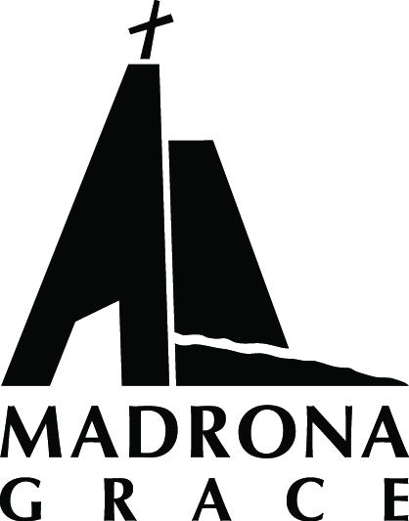
Madrona Grace Presbyterian Church www.madronagrace.org
Intern Wanted
10-15 hrs/week for 9 or 12 months

Madrona Grace is a small, ordinary church in the Madrona Neighborhood that is made up of extraordinary people. We are looking for a creative, thoughtful and well-organized intern to be a part of our pastoral team. This intern will help support our regular faith-formation programs while also working on the implementation of a new initiative called “The Madrona Commons” in which we are making our building more accessible to our immediate neighborhood. Some compensation is available for this flexible position (DOE).
Requirements:
- A mature faith
- A progressive and inclusive theological orientation
- Cultural competence
- An understanding of LGBTQ culture
- Must love children, youth, and young adults.
- Must love Jesus
Possible responsibilities:
- Lead our team of eight teachers in improving our Sunday morning Children’s workshops
- Work with a Session member (leadership team) to organize and facilitate theology on tap events at local pubs.
- Develop and lead program at our Fall Retreat the first weekend in October.
- Assist our nursery worker in implementing a Godly Play curriculum for very small children.
- Do local outreach for the Madrona Commons and coordinate the use of the building throughout the week.
- Help promote and build tiny houses for homeless people (another new initiative).
- Preach! Lead worship. Visit shut-ins. Pray with people. Teach the bible. Be a pastor.
For more information contact Pastor Mark Zimmerly: 206.317.4641 mark@madronagrace.org

